**Assignment no 3**

**Application Form**

**Explanation:**

**Main Components of the Code**

1. **Banner Section:**
   * Displays the title *"Application Form"* at the top of the window.
   * Styled with blue background and white italic text.
   * Centered horizontally and has a fixed height of 100.
2. **Labels and Input Fields:**
   * **Name, Father's Name, CNIC:** These are Text Field input boxes where the user enters their details.
   * **Date:** A Date Picker allows the user to select a date (e.g., their birthdate).
   * **Gender:** Two Radio Button options ("Male" and "Female") are grouped together to ensure only one can be selected at a time.
   * **City:** A Combo Box dropdown menu allows the user to choose from a list of cities.
   * **Image:** Users can upload an image file using the File Chooser. A small preview of the image is displayed in the interface.
3. **Save and Exit Buttons:**
   * **Save Button:**
     + Saves the entered data into an Array List of type User Data.
     + Validates that all fields are filled. If any field is missing, an error alert is shown.
     + If all fields are valid:
       - Displays a success message in an alert box.
       - Clears all the input fields and resets the form.
   * **Exit Button:**
     + Closes the application window.
4. **GridPane Layout:**
   * All form elements (labels, input fields, buttons, etc.) are arranged in a grid-like structure using a Grid Pane.
   * The grid has horizontal and vertical gaps for spacing, and elements are placed at specific row and column indices.
5. **Image Upload:**
   * The File Chooser lets the user select an image file from their computer.
   * The image file is displayed in a small Image View area.
   * The uploaded image is stored as a file path in the application.
6. **Data Storage:**
   * The user data is stored in a custom User Data class.
   * The User Data class has fields for:
     + Name
     + Father's Name
     + CNIC
     + Date
     + Gender
     + City
   * The class includes a to String method to format the data for printing.

**How the Code Works**

1. **Start Method:**
   * Sets up the form layout with labels, input fields, and buttons.
   * Configures the Grid Pane to organize elements in rows and columns.
   * Adds a banner at the top using a Border Pane.
2. **User Input:**
   * Users can fill in the fields, choose a gender, pick a date, select a city, and upload an image.
3. **Save Button Action:**
   * When the user clicks the "Save" button:
     + The application checks if all fields are filled.
     + If valid:
       - Data is saved into the Array List and printed in the console.
       - A success alert is displayed.
       - All fields are cleared for the next entry.
     + If invalid:
       - An error alert shows which fields are missing.
4. **Exit Button Action:**
   * Clicking "Exit" closes the application.

**What Happens in the User Data Class?**

* Stores the user data as fields.
* The toString method formats the data for easy printing (e.g., in the console or logs).

**Key Points:**

* **Layouts Used:**
  + Border Pane for the overall structure (Banner on top, form in the center).
  + Grid Pane for arranging form elements in rows and columns.
  + Box for organizing the image preview.
* **Validation:**
  + Ensures no field is left empty before saving.
* **Image Handling:**
  + Uses File Chooser for selecting an image and displays it in an Image View.
* **Styling:**
  + Background colors, font styles, and spacing are added for better user experience.

**Example Workflow**

1. Run the application.
2. Fill out the fields (Name, Father's Name, CNIC, etc.).
3. Select a date from the date picker.
4. Choose a city from the dropdown menu.
5. Upload an image.
6. Click "Save."
   * If valid, a success alert is shown, and the fields are cleared.
   * If not, an error alert is displayed.
7. Click "Exit" to close the application.

Output

On running the code

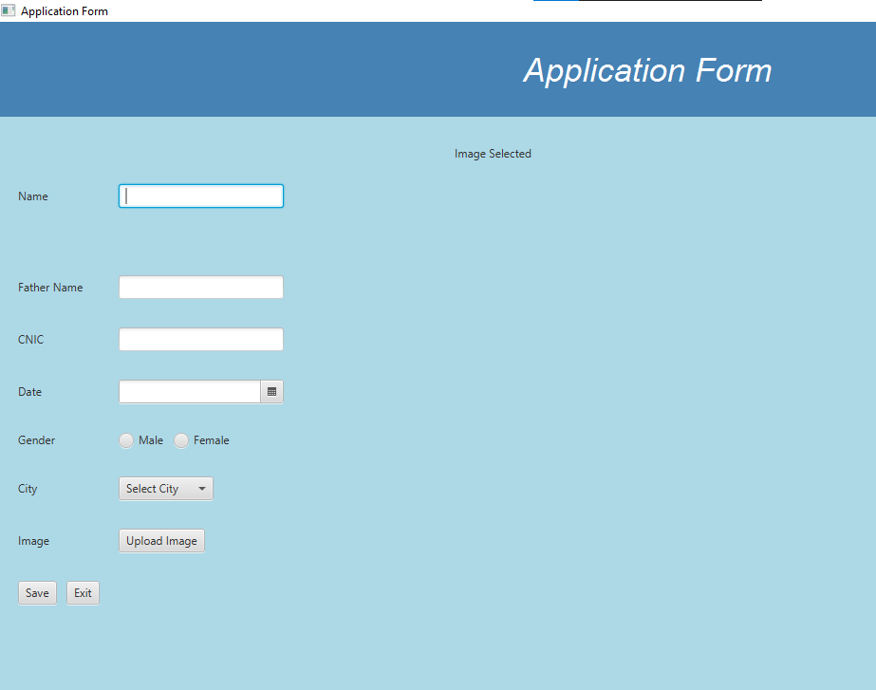

On Filling

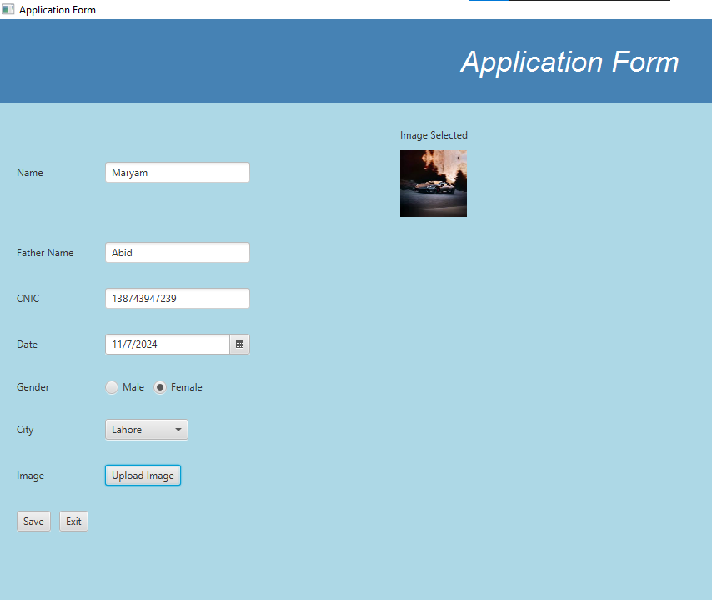

On Saving

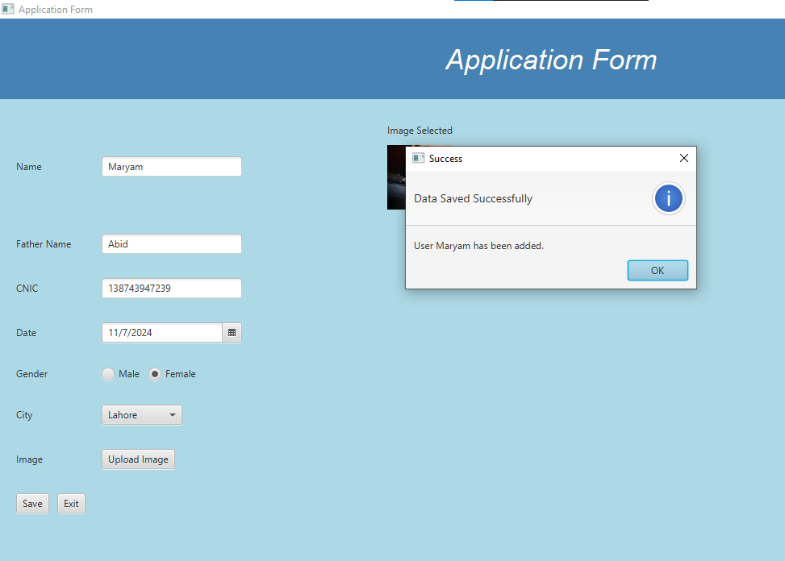

Not Filled Field

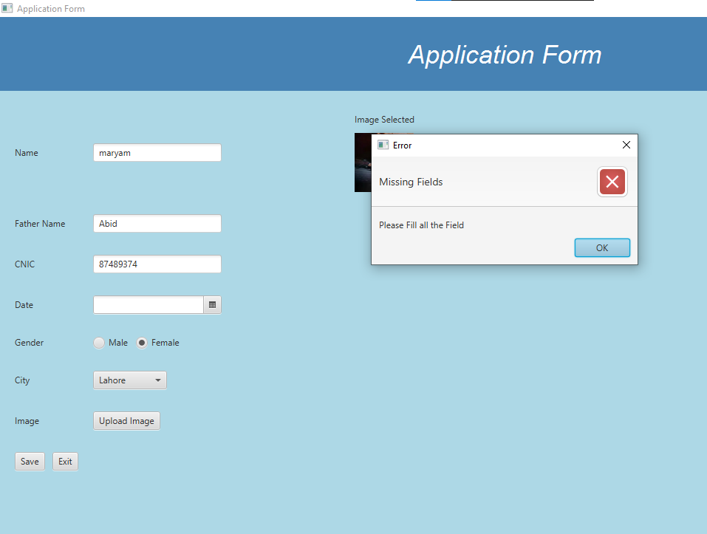

The End